**Question 1:**

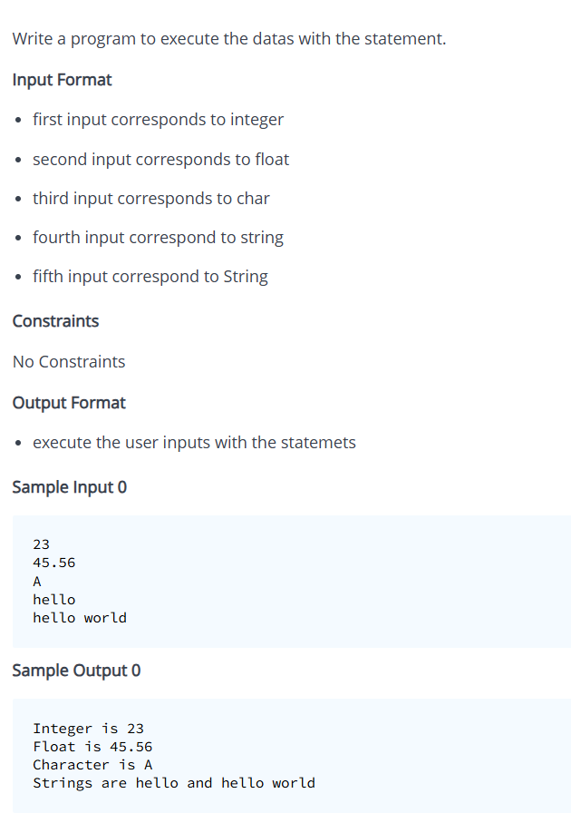

**Solution:**

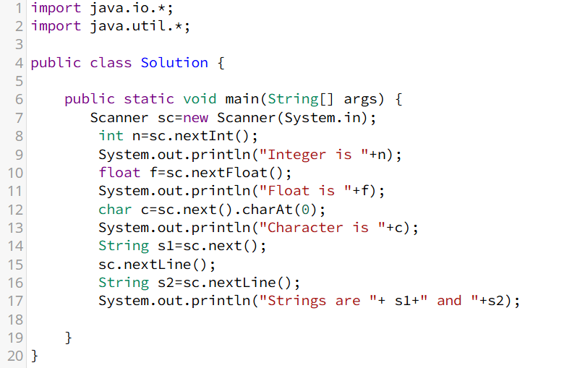

**Question 2:**

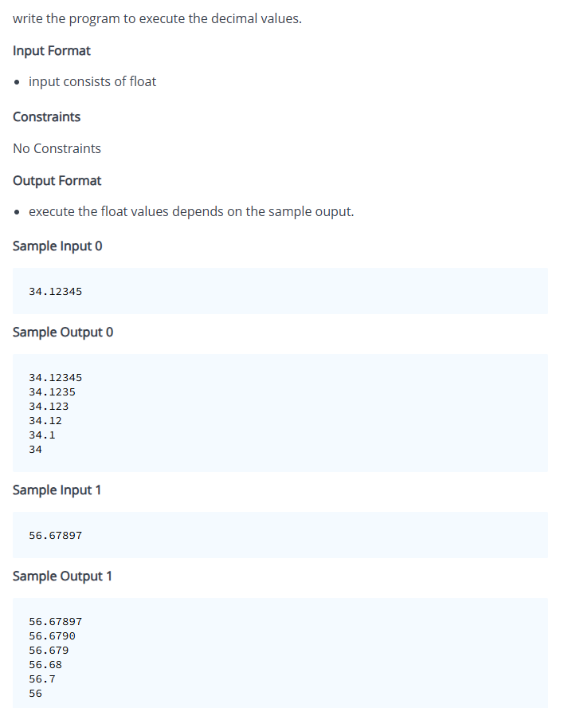

**Solution:**

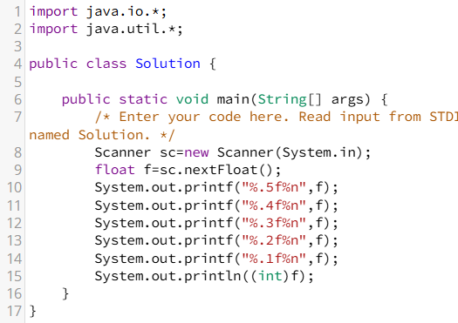

**Question 3:**

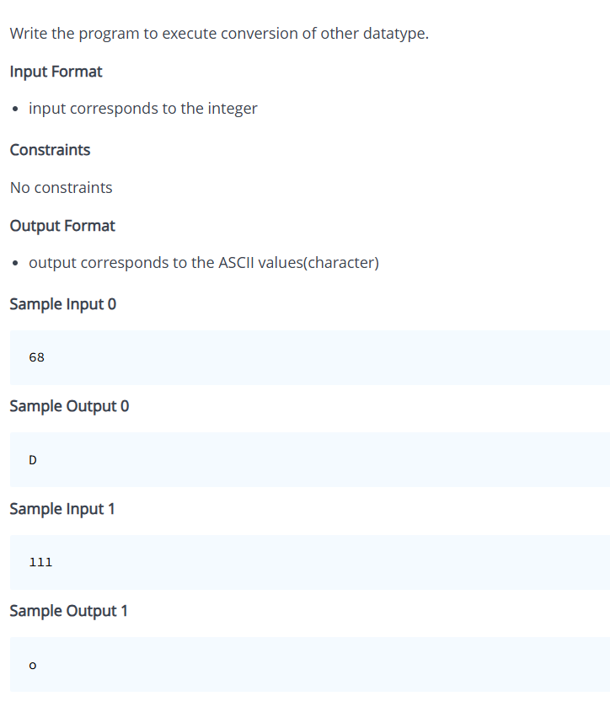

**Solution:**

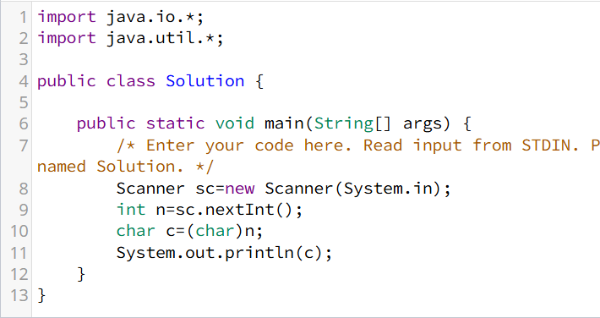

**Question 4:**

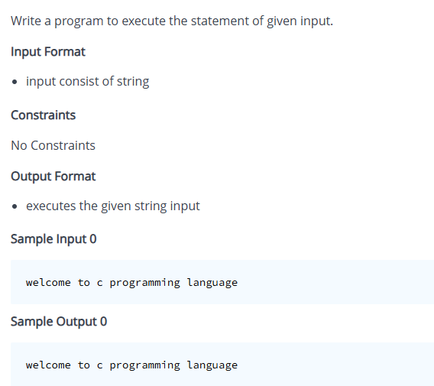

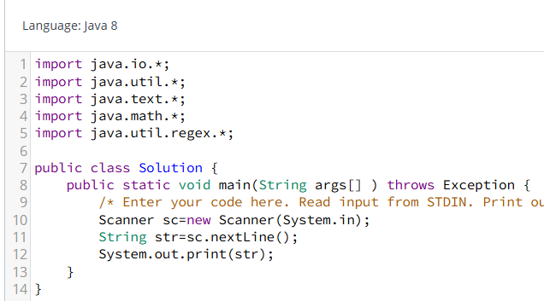

**Question 5:**

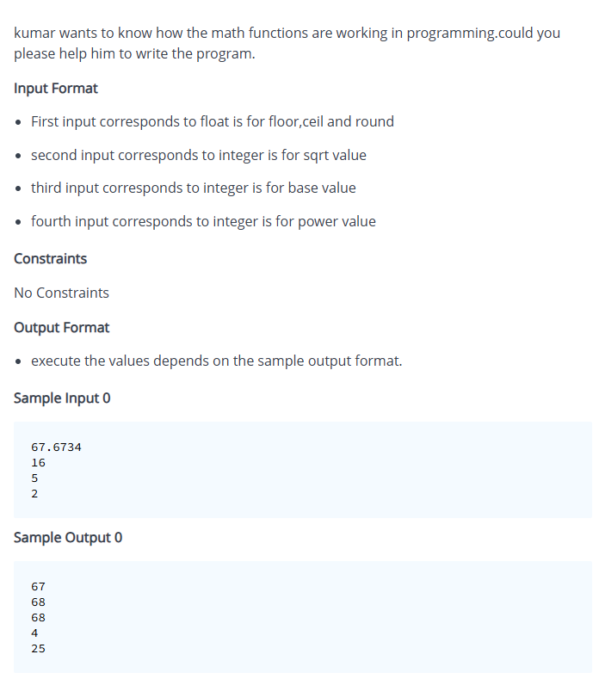

**Solution:**

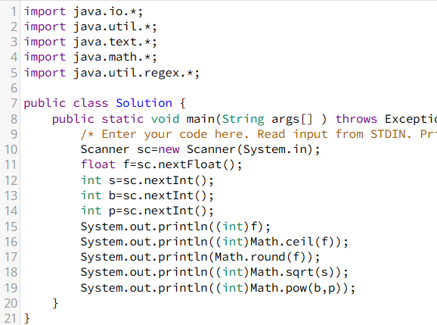

**Question 6:**

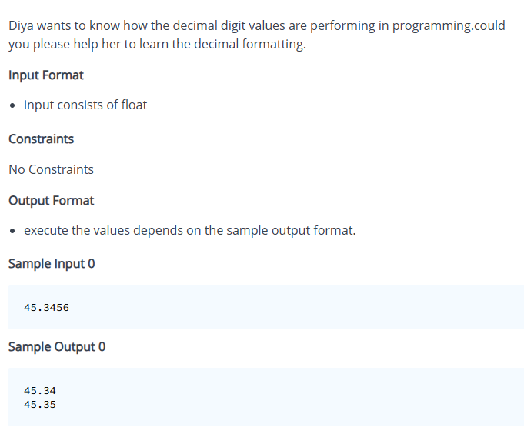

**Solution:**

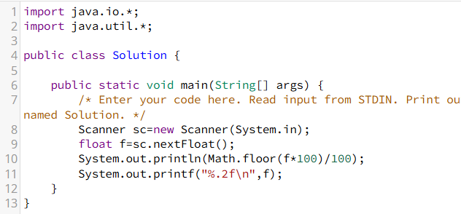

**Question 7:**

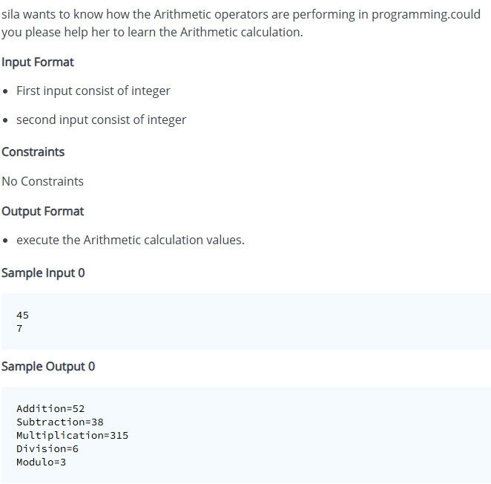

**Solution:**

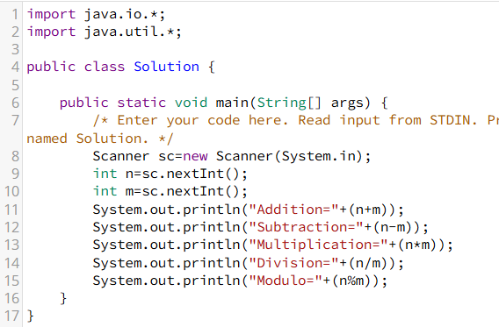

**Question 8:**

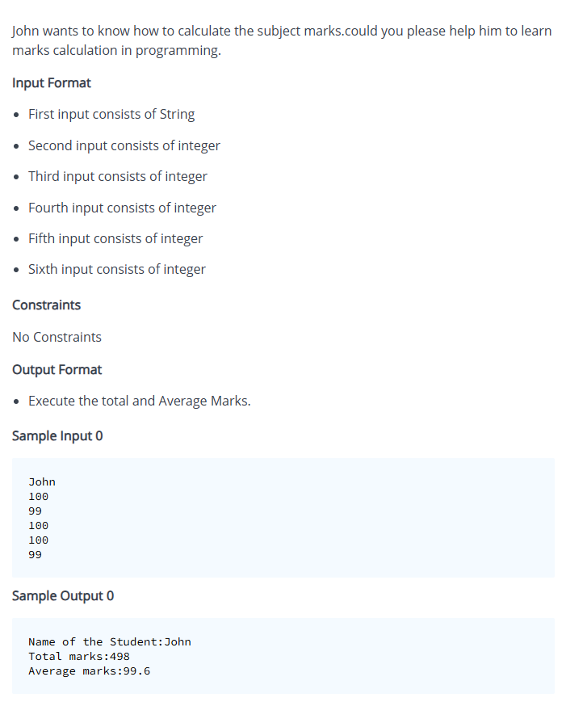

**Solution:**

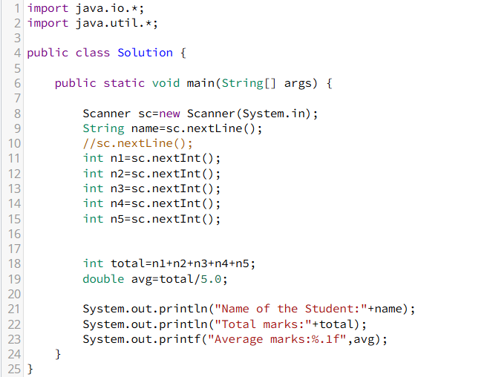

**Question 9:**

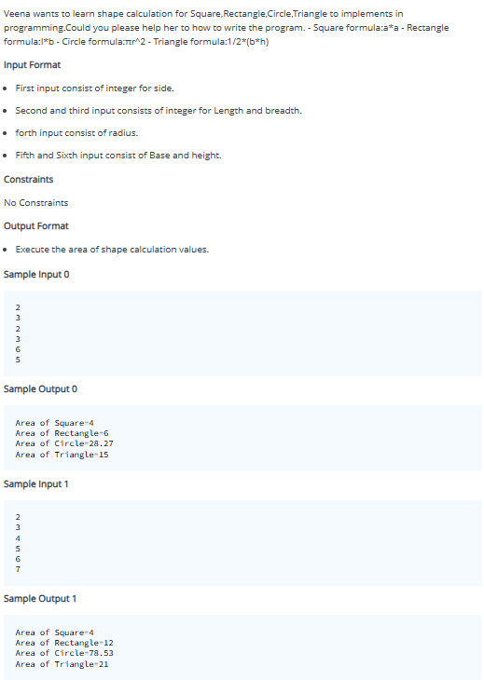

**Solution:**

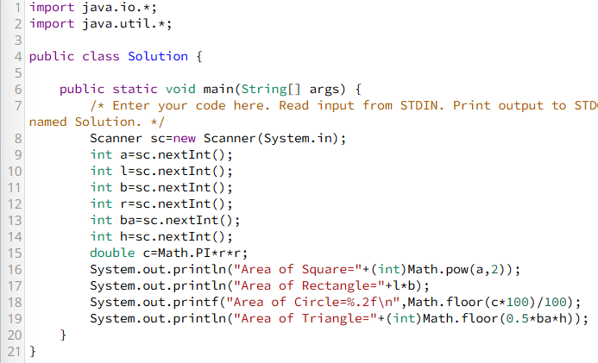

**Question 10:**

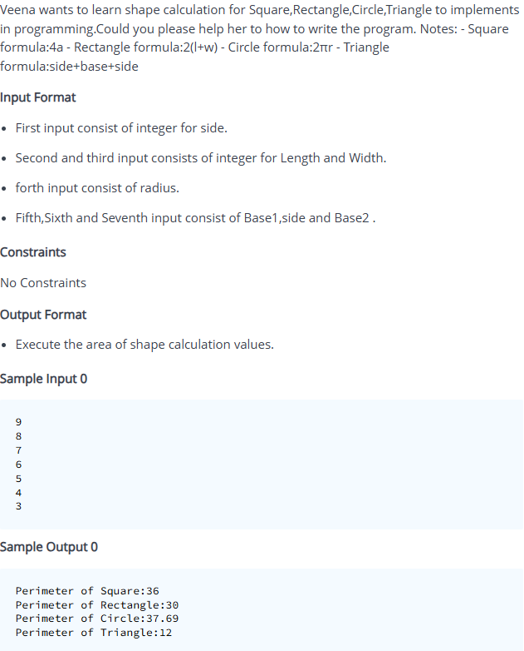

**Solution:**

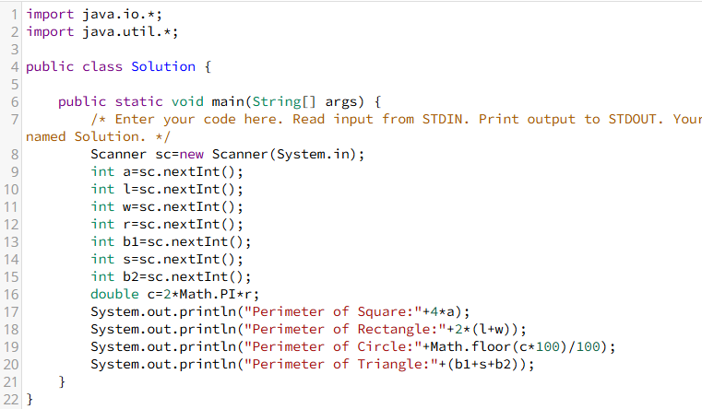

**Question 11:**

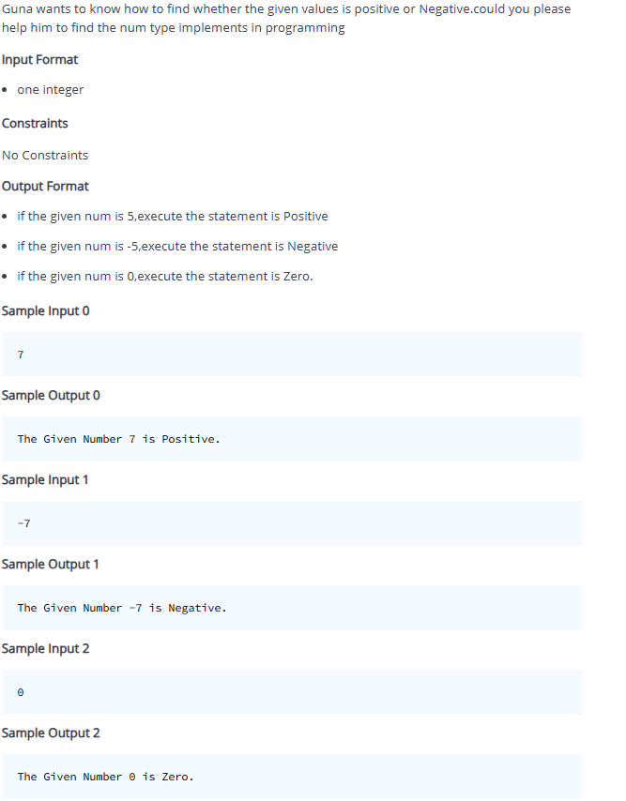

**Solution:**

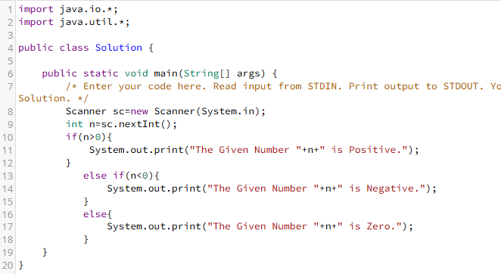

**Question 12:**

Dheena wants to know how the grading marks will works in education.could you please help him to learn the grading System. Note:-

* 100=Grade is S
* 90-99=Grade is A
* 80-89=Grade is B
* 70-79=Grade is C
* 60-69=Grade is D
* 50-59=Grade is E
* <50=Fail

Get the subject marks from the user,then Find the average marks.Based on the average marks generate the Students grade marks.

Input Format

* First input consists of String
* Second input consists of integer
* Third input consists of integer
* Fourth input consists of integer
* Fifth input consists of integer
* Sixth input consists of integer

Constraints

No Constraints

Output Format

* execute the total Marks,average marks and Grade Mark

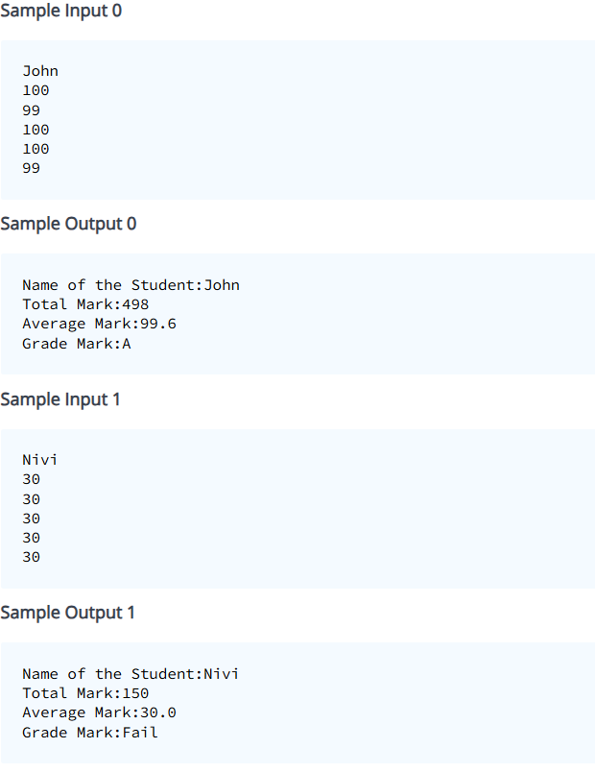

**Solution:**

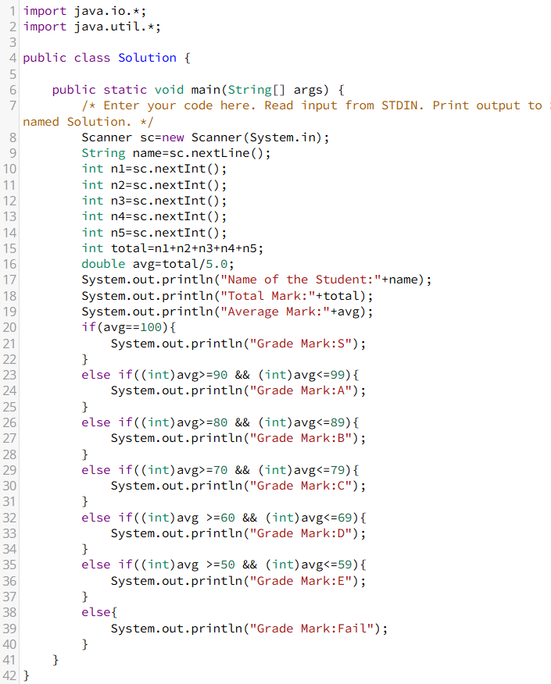

**Question 13:**

Sanjay wants to learn the calculation of integer digits.could you please help him to implements the sum of digits in programming. Notes:- - If the integer is 45,separate the each digits (4+5) the output is 9.

**Input Format**

* input consists of one integer.

**Constraints**

* Given N is greater than 9 and lesser than 99

**Output Format**

* execute the sum of digits values. Notes:-
* If the input is above 100, execute the statements is "Invalid Input".

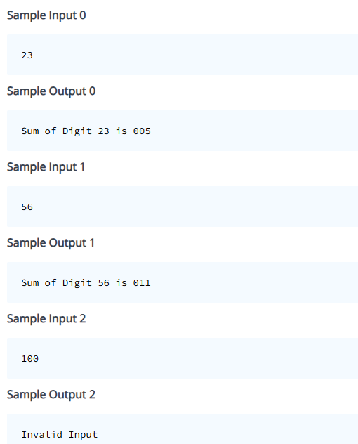

**Solution:**

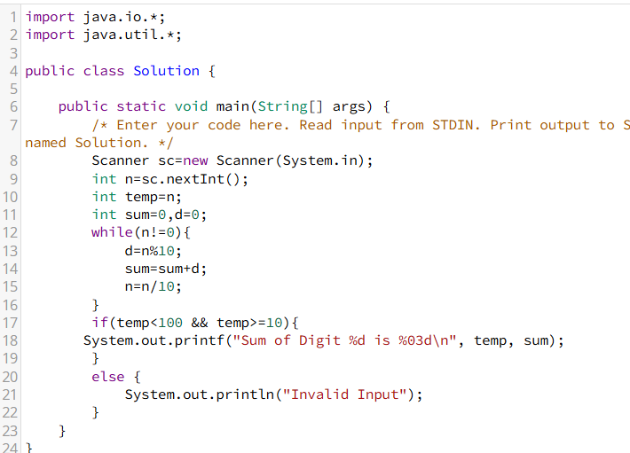

**Question 14:**

Sela wants to learn the alphabets type to implements in the program.could you please her to implements the program.

**Input Format**

* input consists of Character

**Constraints**

No Constraints

**Output Format**

* if the Given input is A,print the statement is "Upper Case".
* if the Given input is a,print the statement is "Lower Case".
* if the Given input is 2,print the statement is "Number".
* if the Given input is &,print the statement is "Symbol".

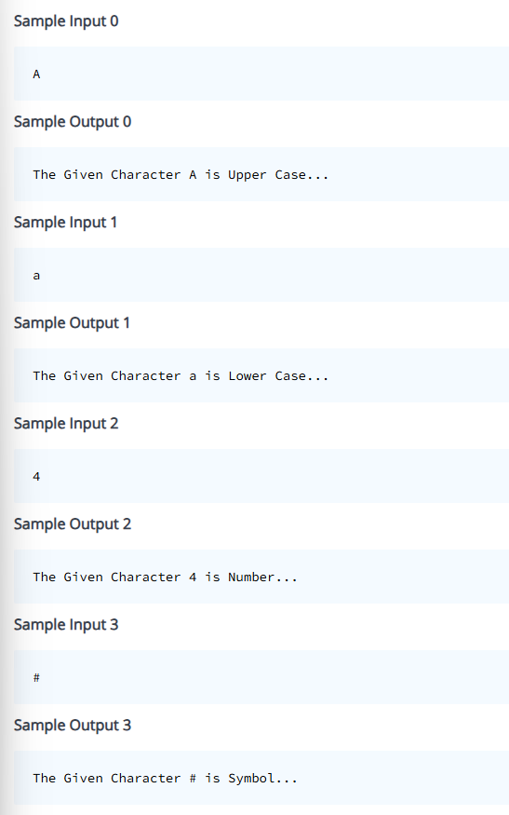

**Solution:**

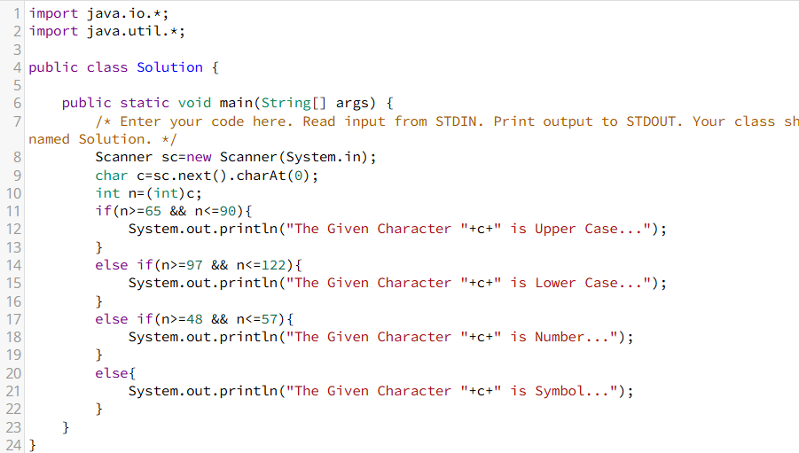

**Question 15:**

Deepak wants to know how to find whether the year is leap year or not.could you please help him to find the year is leap year or not. - A century year is a year ending with 00. A century year is a leap year only if it is divisible by 400. - A leap year (except a century year) can be identified if it is exactly divisible by 4. - A century year should be divisible by 4 and 100 both. - A non-century year should be divisible only by 4.

**Input Format**

* input consists of integer

**Constraints**

No Constraints

**Output Format**

* execute the statemene whether the given year is leap or not.

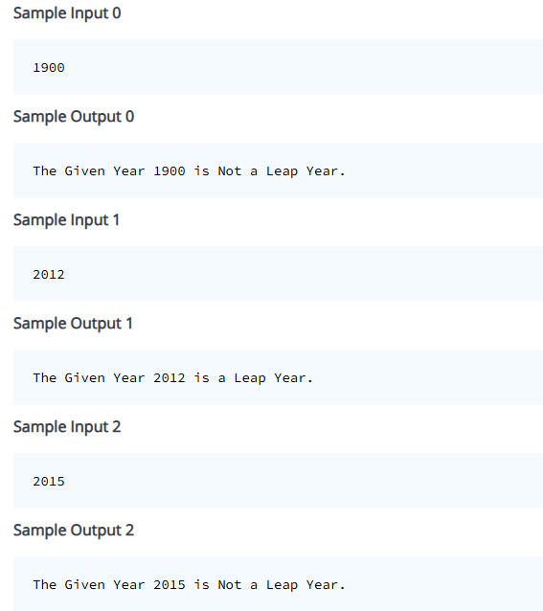

**Solution:**

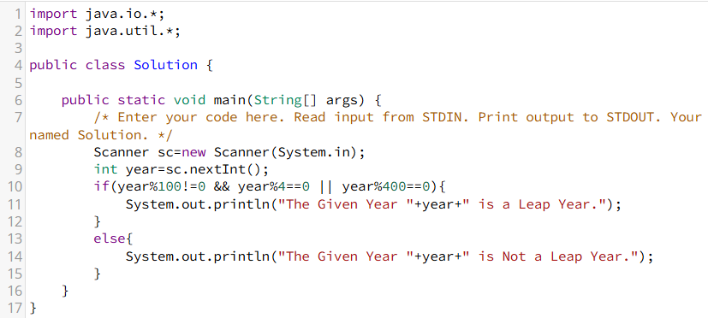

**Question 16:**

Maya wants to know how to find whether the alphabet is Vowel or Consonant.could you please help her to find the alphabet is Vowel or Consonant.

Input Format

* input consists of one Character.

Constraints

No Constraints

Output Format

* print whether the character is Vowel or Consonant or Invalid Input.

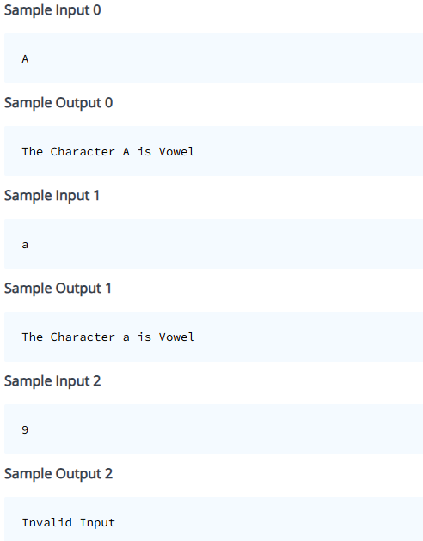

**Solution:**

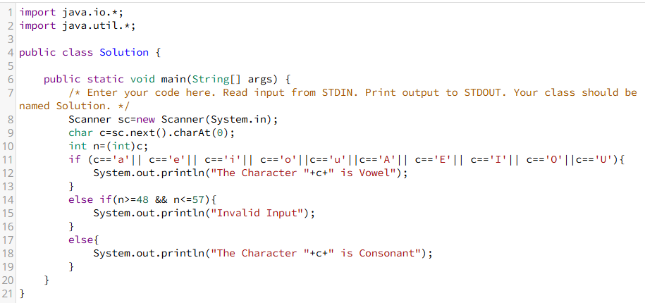

**Question 17:**

Kumar wants to learn how the calculators are working.so he is trying to implements the calculator program.could you please help him to implements the program. - Notes:- Must use the Switch Case.operators - Addition - Subtraction - Multiplication - Division - Modulo

**Input Format**

* First input consists of integer.
* Second input consists of integer.
* third input consists of character.

**Constraints**

No Constraints

**Output Format**

* print the calculation Value.
* if the symbol is not the arithmetic operator,print the statement is "Invalid Input".

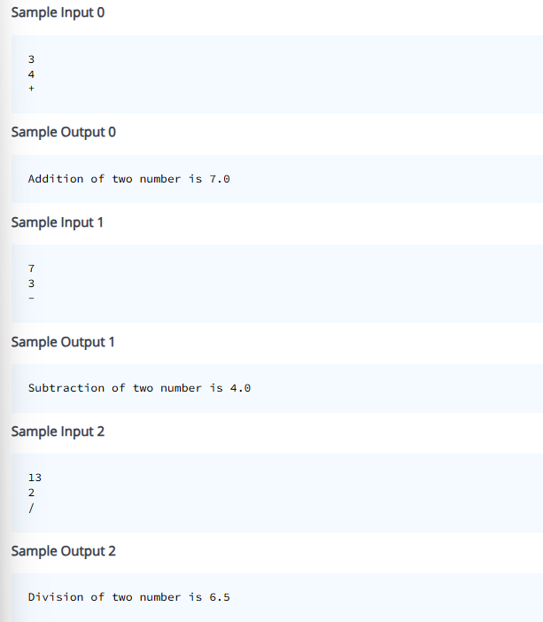

**Solution:**

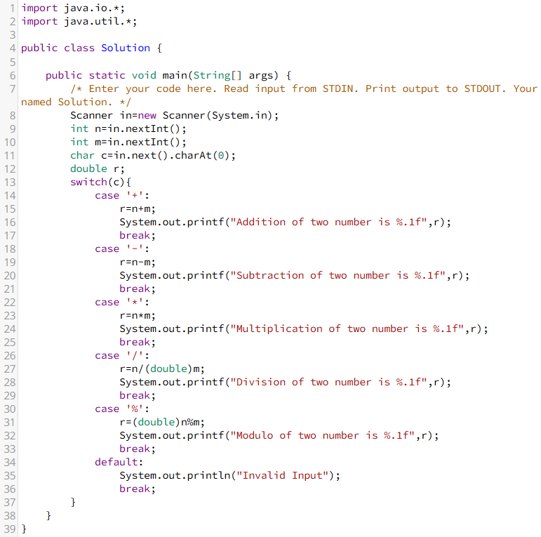

**Question 18:**

Riya wants to find the greatest of three numbers.could you please help her to find the greatest of three numbers that implements in programming.

**Input Format**

* Input consists of three integer.

**Constraints**

No Constraints

**Output Format**

* print the greatest of three Number.

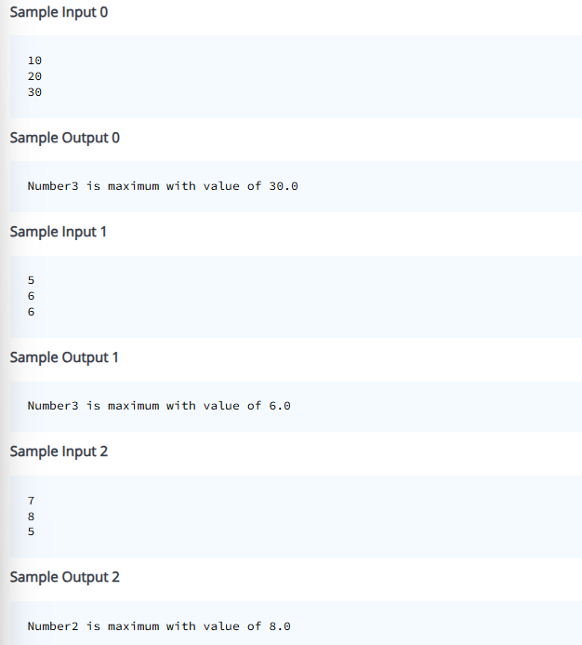

**Solution:** 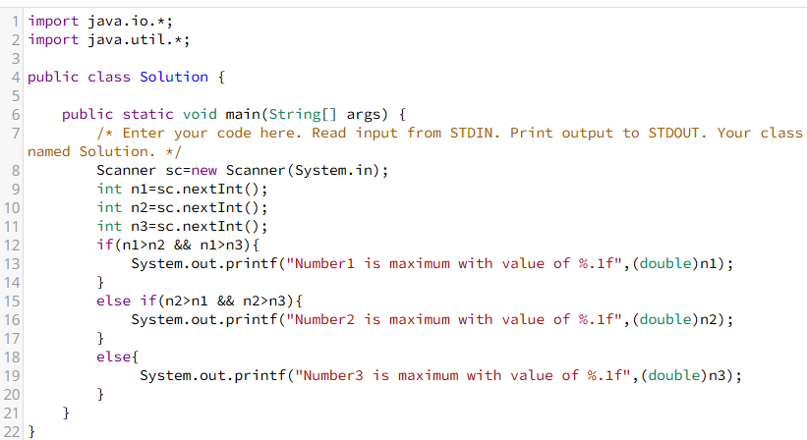

**Question 19:**

Maya wants to know how the Numbers are converted to string in the program.could you please help her to implements the program.

**Input Format**

* input consists of one integer

**Constraints**

* Given N is greater than 0 and lesser than 9

**Output Format**

* print the number into string type.

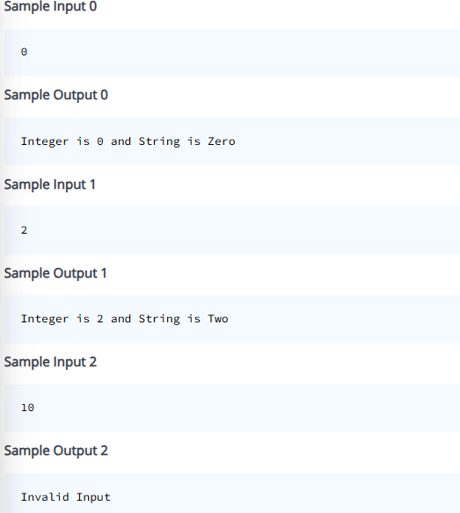

**Solution:**

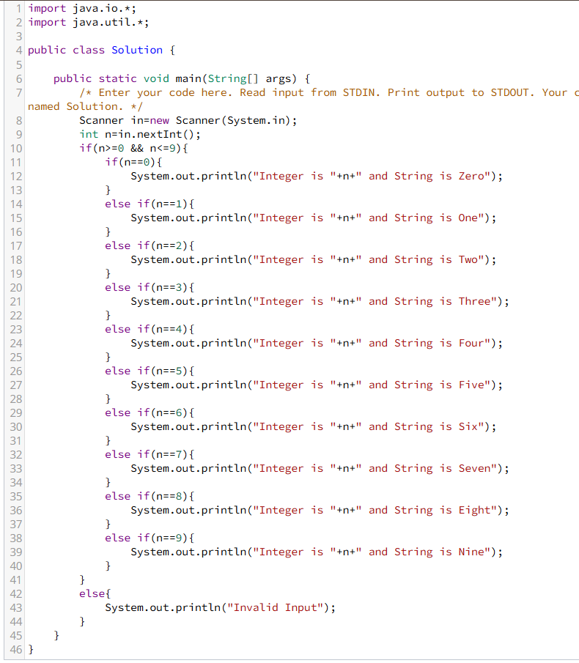

**Question 20:**

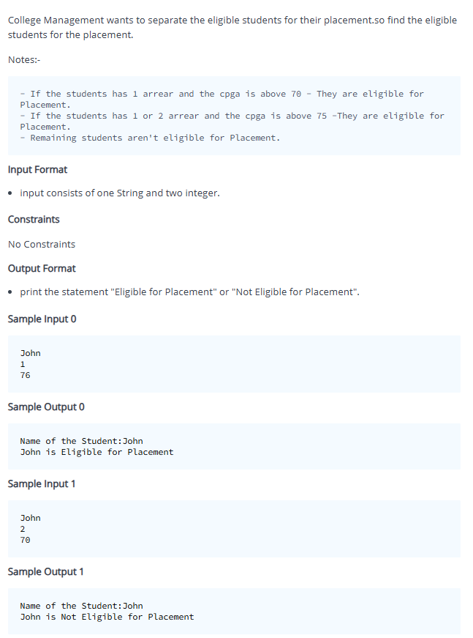

**Solution:**

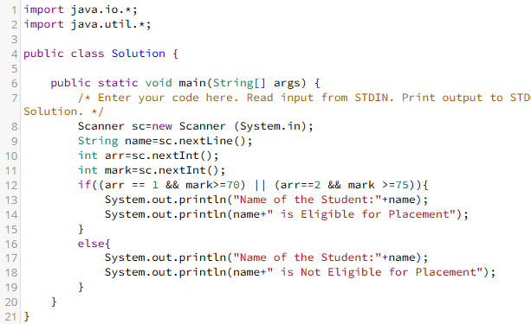

**Question 21:**

Riya wants to find the sum of range values. could you please help her to implements the program.

Input Format

* input consists of two integer

Constraints

No Constraints

Output Format

* print the sum of range values.

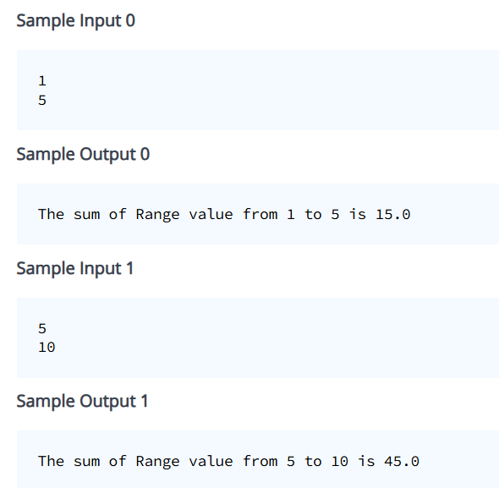

**Solution:**

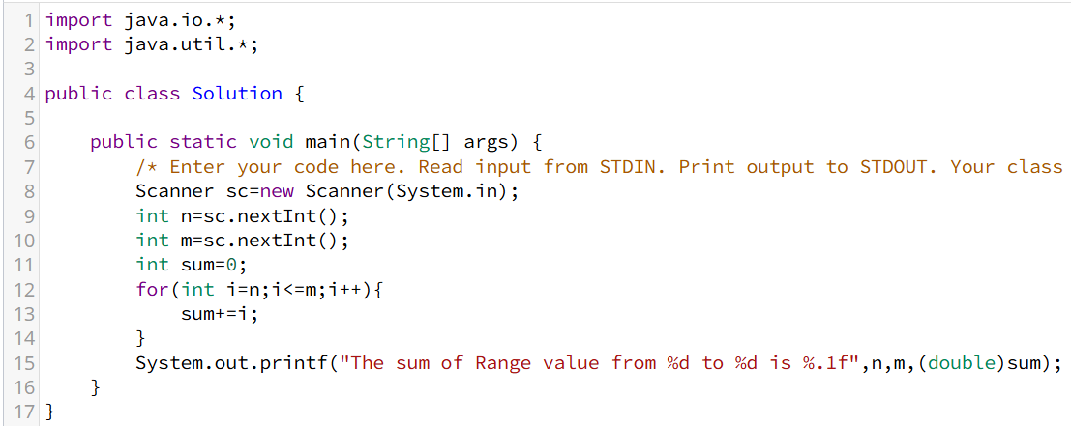

**Question 22:**

Seela wants to find the sum of even and odd numbers in the between range values.could you please help her to implements the program.

**Input Format**

* Input consists of two integer.

**Constraints**

Given N is greater than 1 and lesser than 100.

**Output Format**

* Print the sum of even num and odd num.

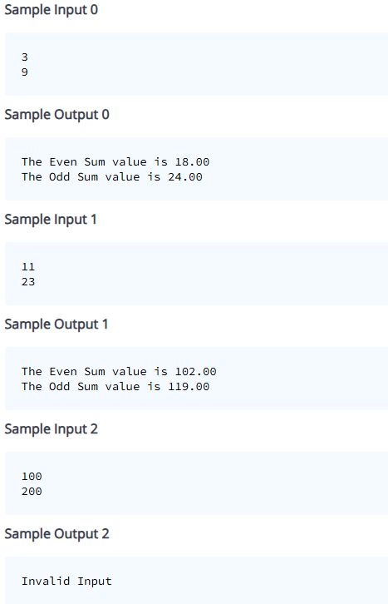

**Solution:**

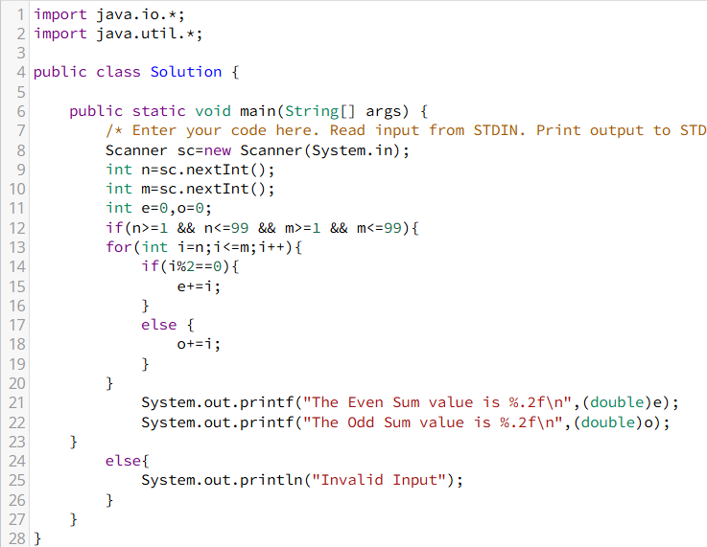

**Question 23:**

A factorial is the product of all the natural numbers less than or equal to the given number n.Sheela wants to know how its working in programming.

For Example,

The factorial of 6 is 6 * 5 * 4 * 3 * 2 * 1 which is 720.

could you please help her to write the program to find the factorial of a number.

**Input Format**

* Input consists of one integer

**Constraints**

Given N is non Negative values.

**Output Format**

* print the factorial Values

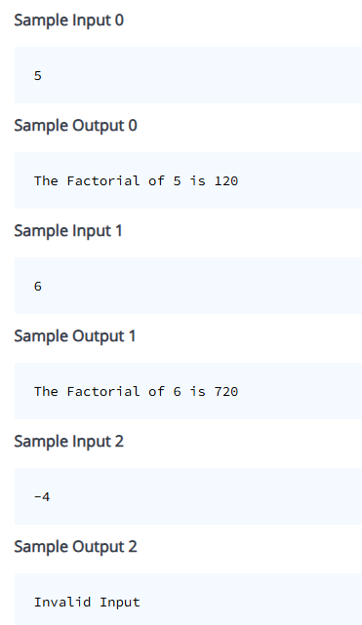

**Solution:**

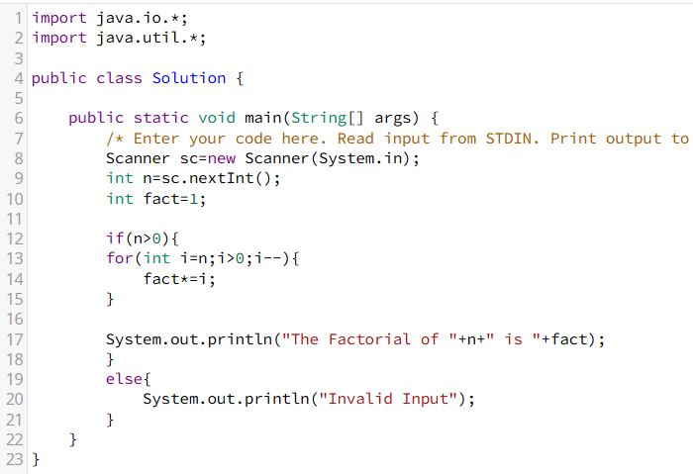

**Question 24:**

Veena wants know to whether the given number is perfect number or not.could you please help her to find it and implements in program.

* If the Sum of proper factor is equals to the given number,its a perfect number.

For example,Proper factor of 6 is 1,2,3=>(1+2+3)=6

sum of factor is 6 and the given number is also 6 so its a perfect number.

**Input Format**

* integer consists of one integer.

**Constraints**

Given N is Non Negative Numbers

**Output Format**

* Execute the statement "Perfect Number" or "Not Perfect Number".

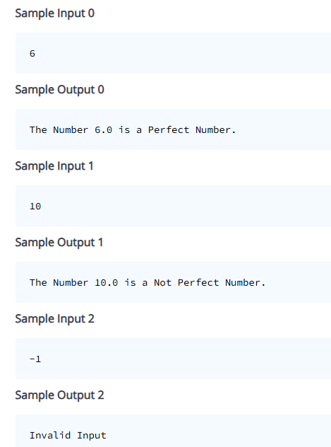

**Solution:**

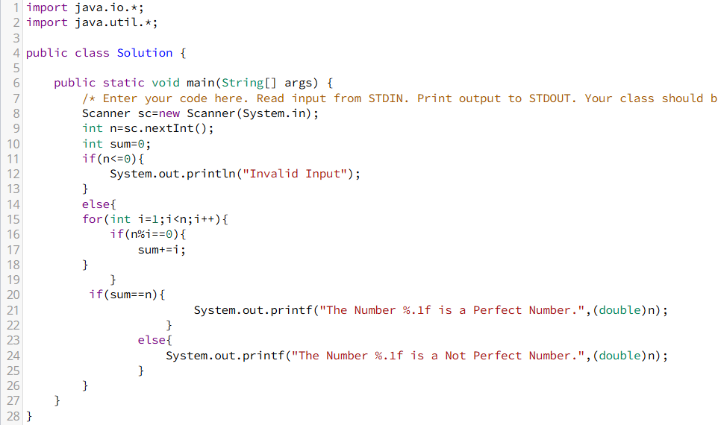

**Question 25:**

Sanjay wants to know whether the user input is Automorphic number or not.

For example,

The Automorphic number is square of the number ends with the Same number.

Square of 5 is 25,its ends with the value of 5.

so the number 5 is Automorphic Number.

could you please help him to find it and implements in program.

**Input Format**

* Input consists of one integer

**Constraints**

Given N is greater than 1 and lesser than 9.

**Output Format**

* Print the statement whether the given number is "Automorphic Number" or "Not Automarphic Number".

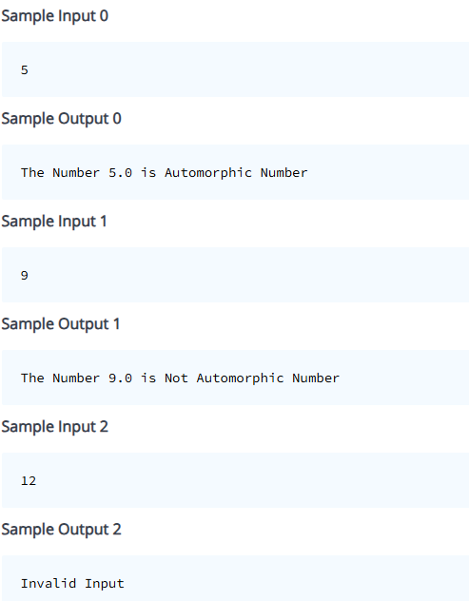

**Solution:**

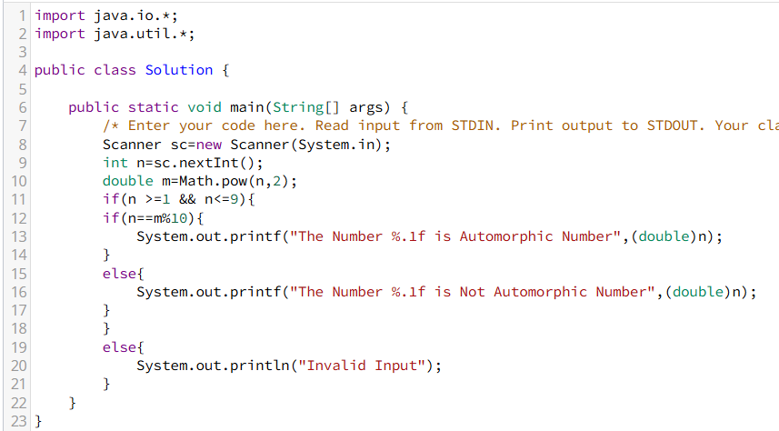

**Question 26:**

A number n is said to be an Abundant Number if the sum of all the proper divisors of the number denoted by sum(n) is greater than the value of the number n.

For example,

If the Number is 12,the proper divisors are 1,2,3,4,6

Now,sum of proper divisors is 1+2+3+4+6=16

Implements the program to find the number is Abundant or Not.

**Input Format**

* Input consists of one integer

**Constraints**

No Constraints

**Output Format**

* Print the statement whether the given number is "Abundant Number" or "Not Abundant Number".

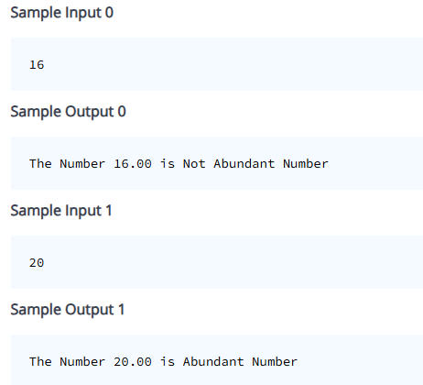

**Solution:**

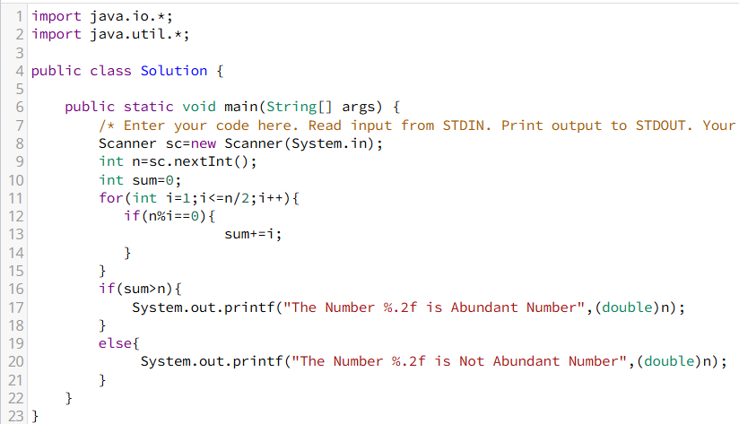

**Question 27:**

Riya wants to clear the logical Reasoning in the Placement.she has a doubt in the topic of series number.She didn't to how to execute the series number and how to calculate it.Could you please help her to implements the program.

**Input Format**

* input consists of one integer.

**Constraints**

No Constraints

**Output Format**

* Execute the series of numbers.

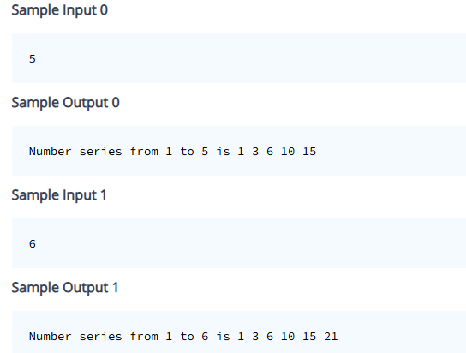

**Solution:**

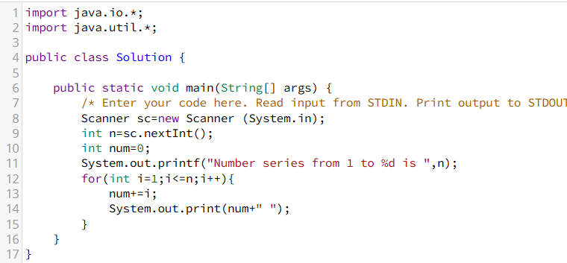

**Question 28:**

Riya wants to clear the logical Reasoning in the Placement.she has a doubt in the topic of series number.She didn't to how to execute the series number and how to calculate it.Could you please help her to implements the program.

**Input Format**

* input consists of one integer.

**Constraints**

No Constraints

**Output Format**

* Execute the series of numbers.

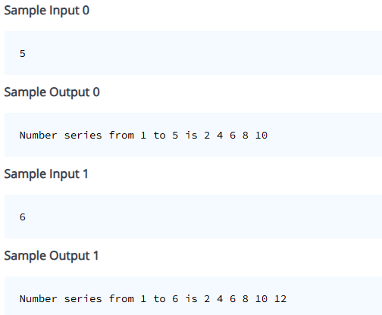

**Solution:**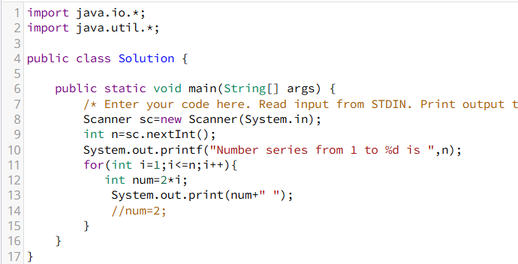

**Question 29:**

Riya wants to clear the logical Reasoning in the Placement.she has a doubt in the topic of series number.She didn't to how to execute the series number and how to calculate it.Could you please help her to implements the program.

**Input Format**

* Input consists of one integer.

**Constraints**

No Constraints

**Output Format**

* Execute the series of numbers. 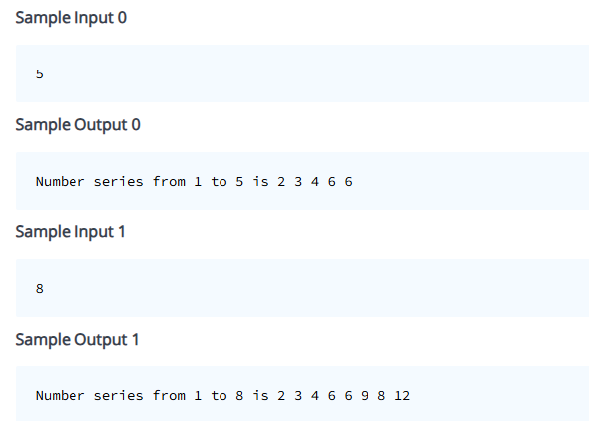

**Solution:**

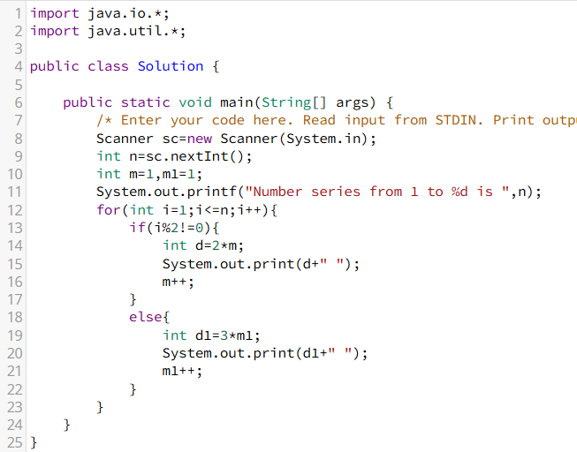

**Question 31:**

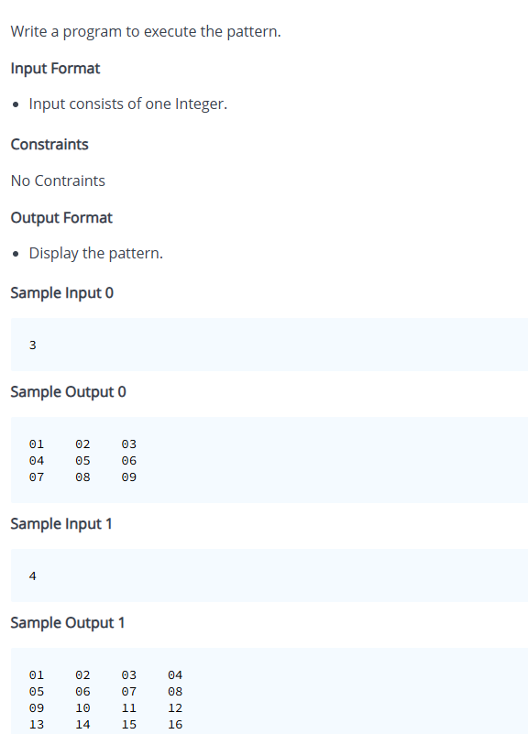

**Solution:**

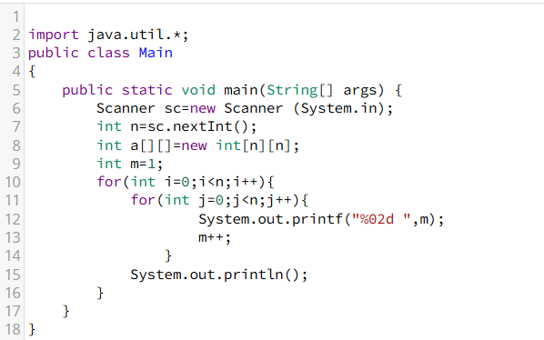

**Question 32:**

Write a program to execute the pattern.

**Input Format**

* Input consists of one Integer.

**Constraints**

No Contraints

**Output Format**

* Display the pattern.

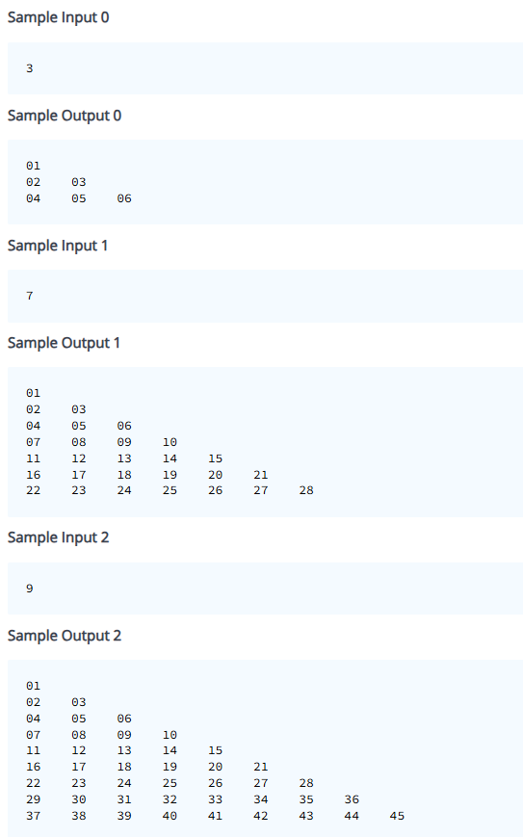

**Solution:**

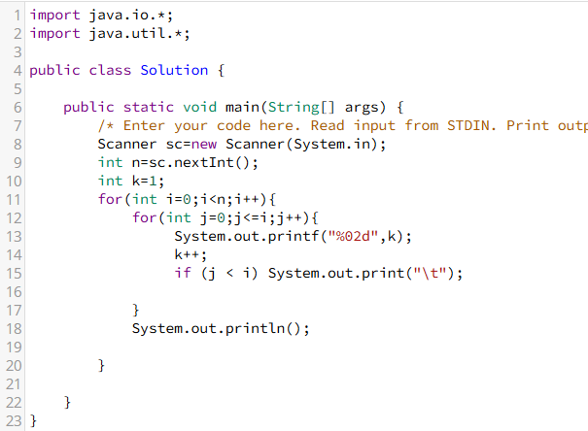

**Question 33:**

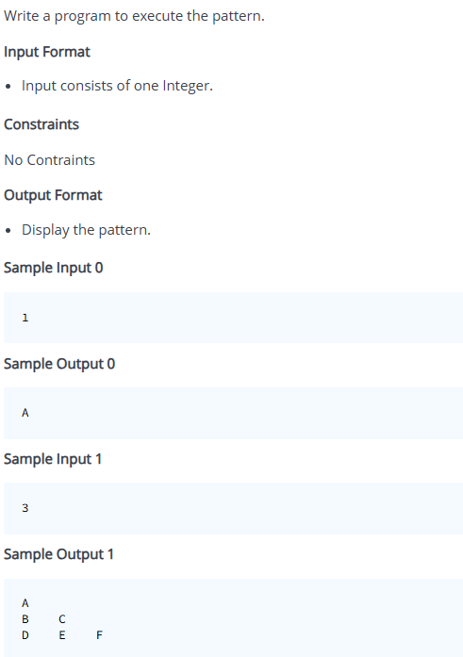

**Solution:**

